**Car Sales Prediction**

Programming Languages:-

Python

Installation of the software and setups: -

* Installing VsCode
* Setting up the environment so that it can run the python and jupyter notebook and also libraries for the machine learning

Issues: -

1. Trying to import Csv file from my Github repository to my working environment

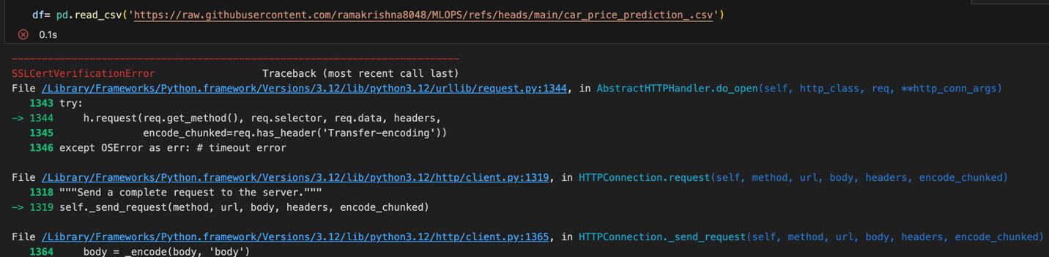

Solution:-

Step1:-

On macOS, Python often requires the installation of additional SSL certificates. This is particularly common when using Python installed via the official installer from python.org.

/Applications/Python\ 3.12/Install\ Certificates.command

(This command will install the required certificates for Python 3.12. The path might vary slightly depending on your Python version, but it's usually under /Applications/Python <version>.)

**Step 2: Verify Installation**

After running the above command, try running your script or Jupyter Notebook again to see if the issue is resolved.

**Step 3: (Optional) Disable SSL Verification (Not Recommended for Production)(Not recommended)**

If you’re working in a development environment and want to bypass SSL verification (not recommended for production due to security risks), you can disable it:

1. Modify the code making the request to skip SSL verification. For example, if you're using urllib or requests, you can do this:

python

Copy code

import ssl

import urllib.request

ssl._create_default_https_context = ssl._create_unverified_context

urllib.request.urlopen('https://example.com')